Small architecture
I trained first splitting one video frames into train, validation and test. Then, I also tried to train, validate and test with all the videos from just one signer. And then with all videos from all signers.

All keypoints
Using one video, results on testing data [predicted | groundtruth]:
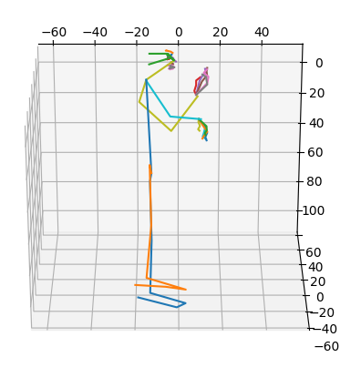
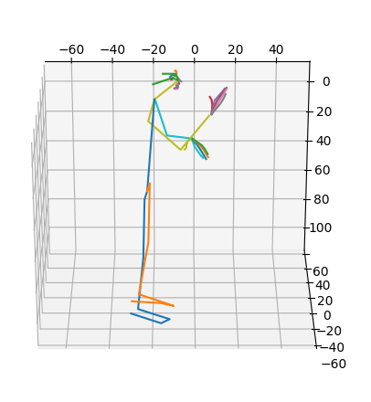
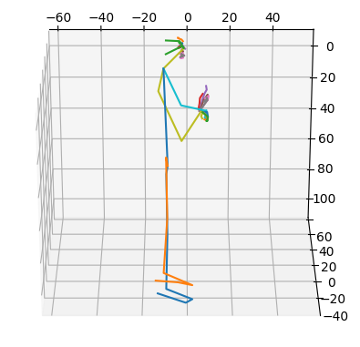
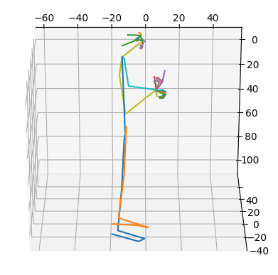
Using all the videos from a signer, results on testing data[predicted | ground-truth]:

Body
Using one video, results on test data [predicted | groundtruth]:
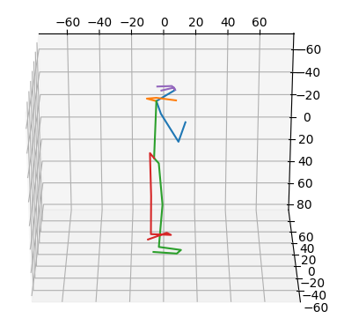
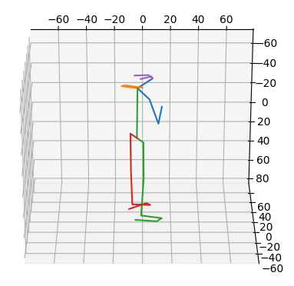

Face
Using one video, results on test data [predicted | groundtruth]:
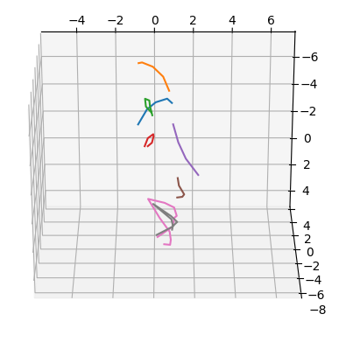
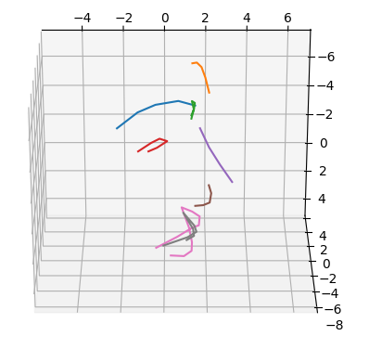

Hands
Using one video, results on testing data [predicted | groundtruth]:
